Project Design Phase-II
Technology Stack (Architecture & Stack)

Date | 8 Feb 2026
Team ID | LTVIP2026TMIDS88463
Project Name | FreelanceFinder : Descovering Opportunities,Unlocking Potential
Maximum Marks | 4 Marks

Technical Architecture:
FreelanceFinder is built on a modular MERN stack architecture designed to provide a secure, scalable, and structured freelancing platform. The system follows a layered architecture model where the React frontend handles user interaction and UI rendering, the Node.js & Express backend manages business logic and API routing, and MongoDB serves as the centralized data storage layer.
User requests flow from the frontend through RESTful APIs (using Axios) to the backend server. Authentication is verified using JWT middleware, and passwords are securely encrypted using Bcrypt before storage. The backend processes project management, proposal handling, freelancer selection, and real-time communication logic before interacting with the MongoDB database. Real-time chat functionality is implemented using Socket.io, enabling instant communication between clients and freelancers while storing chat history in the database.
This layered and modular architecture ensures security, scalability, maintainability, and smooth interaction between Clients, Freelancers, and Administrators while maintaining proper database relationships across Users, Projects, Applications, and Chats.
.
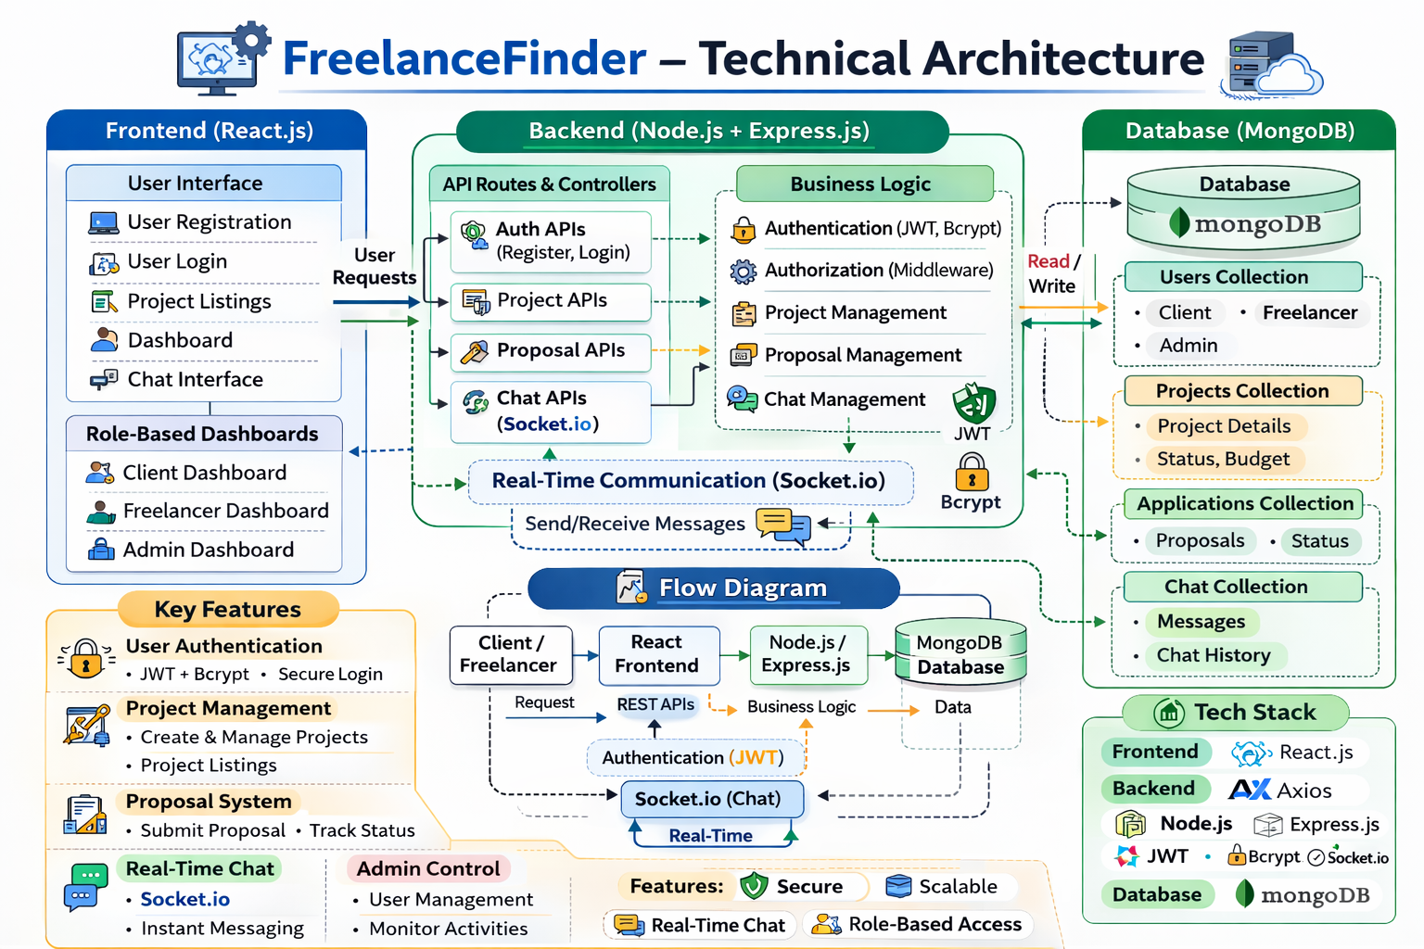
Guidelines:
Be citizen-first: Make it inclusivemultilingual, and easy to use.
Think green: Align with sustainability goals like clean energy and smart mobility.
Protect data: Ensure privacy, transparency, and ethical AI.
Stay flexible: Use modur, scalable, and open-source tech.
Act in real time: Use IoT and AI for instant insights and alerts.
Listen and adapt: Collect feedback and keep improving

Table-1 : Components & Technologies:
S.No | Component | Description | Technology
 | User Interface |  | React.js, HTML, CSS, Bootstrap
  Web-based interactive dashboards for Admin, Teacher,
  and Student
 | Backend Server | Handles routing, authentication, business logic, and API management | Node.js, Express.js
 | Database | Stores users, courses, enrollments, and payment records | MongoDB (Mongoose ORM)
 | Authentication System | Secure login and session management | JWT (JSON Web Token), bcrypt
 | File Upload System | Upload and manage course videos | Multer
 | Payment Module | Simulated payment validation before enrollment | Custom Express API
 | API Communication | Handles frontend-backend communication | RESTful APIs, Axios
 | Role-Based Access Control | Restricts access based on user type (Admin, Teacher, Student) | Middleware (RBAC)
 | Development Environment | Local development and testing | Node.js runtime, npm
 | Infrastructure (Server / Cloud) | Deployment on local server or cloud platforms | AWS / Azure / Render / Docker (Future Ready)

Table-2: Application Characteristics:
S.No | Characteristics | Description | Technology
 | Open-Source Frameworks | Built entirely using open-source technologies | MERN Stack
 | Security Implementations | Password hashing and token-based authentication | Role-Based Access Control
 | Scalable Architecture | Modular backend and component-based frontend | bcrypt, JWT
 | Availability | Can be deployed on cloud with 24/7 availability | express + React Architecture
 | Performance | Optimized database queries and efficient API responses | MongoDB Indexing, Async APIs
 | Maintainability | Clean folder structure and separation of concerns | MVC-like Structure
 | Data Integrity | Schema validation and relationship mapping | Mongoose Schema Validation
 | Future Expandability | Future Expandability | Modular API Design

